1. Linux Operating System

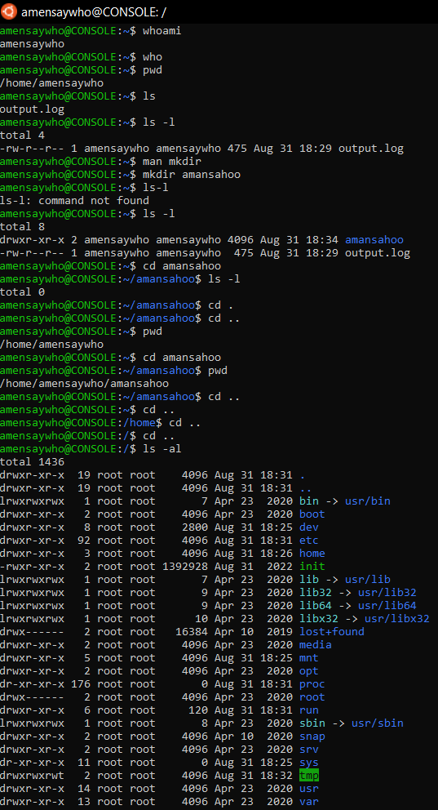

* cd .. takes me to the parent directory ( .. refers to parent directory)
* cd . takes me to the current directory ( . refers to current directory)
* cd / takes me to the root directory
* cd ~ takes me to the home directory of current user
* cd /home takes me to the directory containing all the user folders
* cd $HOME has the same effect as cd ~

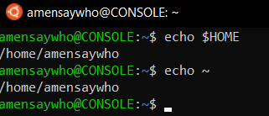

To refer to a directory we can:

* List full directory path
* If directory is in pwd, can use ./
* If directory is subdirectory of home, can use $HOME/ or ~/
* If directory is subdirectory of parent directory of pwd, can use ../

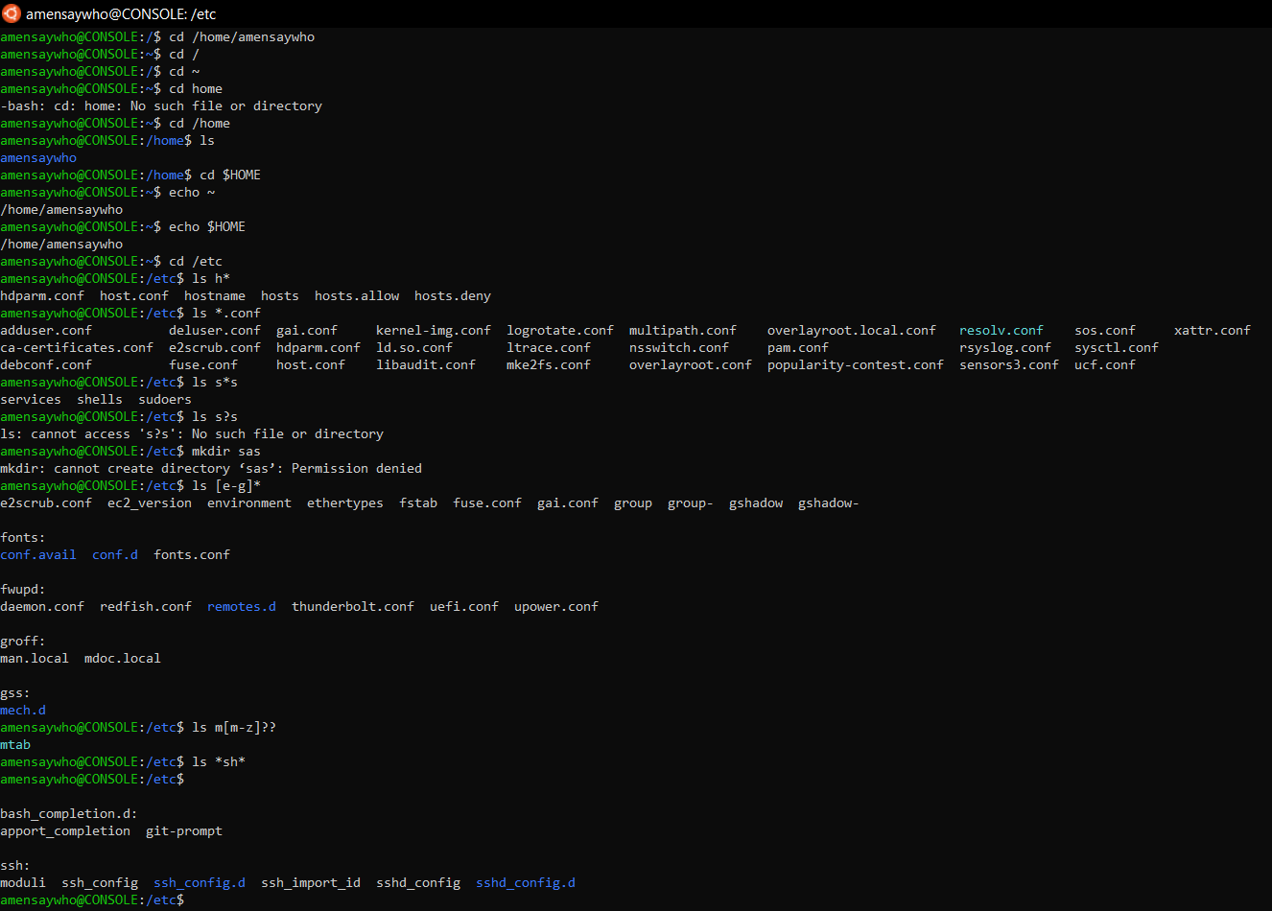

* \* acts as a wildcard search option accepting any length of the string in the given position
* ? looks for entries with single character length in the given position
* [..] looks for entries in the specified range with single character length

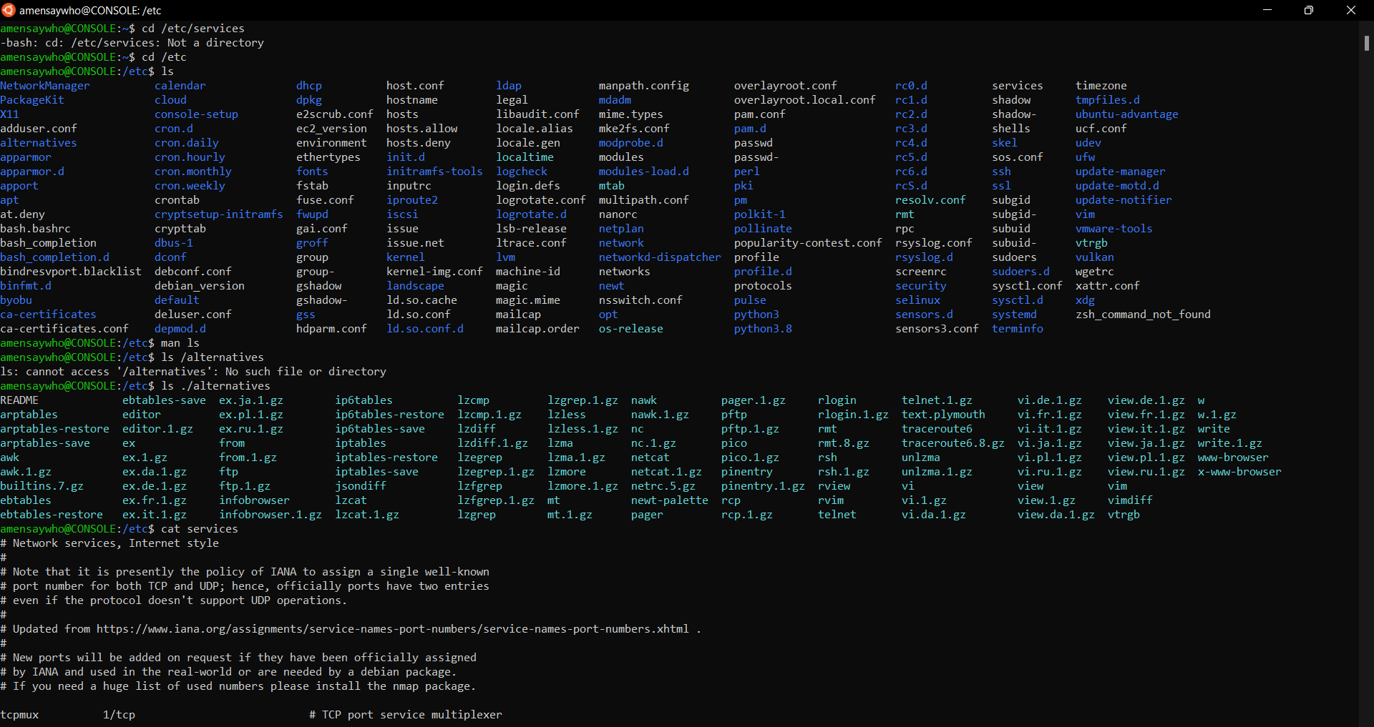

* cat displays the full contents of the file. There are no prompts for “more” or ‘less’ (in Ubuntu)
* tail displays the last few lines of the file
* head displays the first few lines of the file

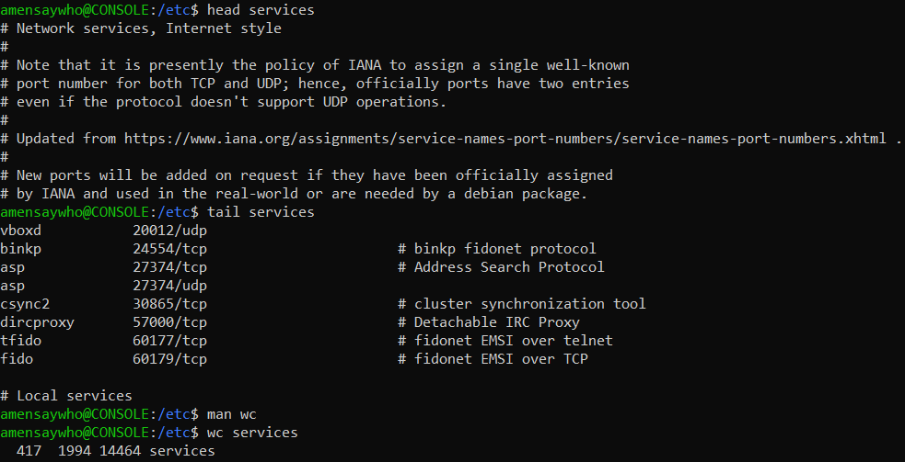

* wc prints the number of lines, words and byte size of the file specified (in that order)

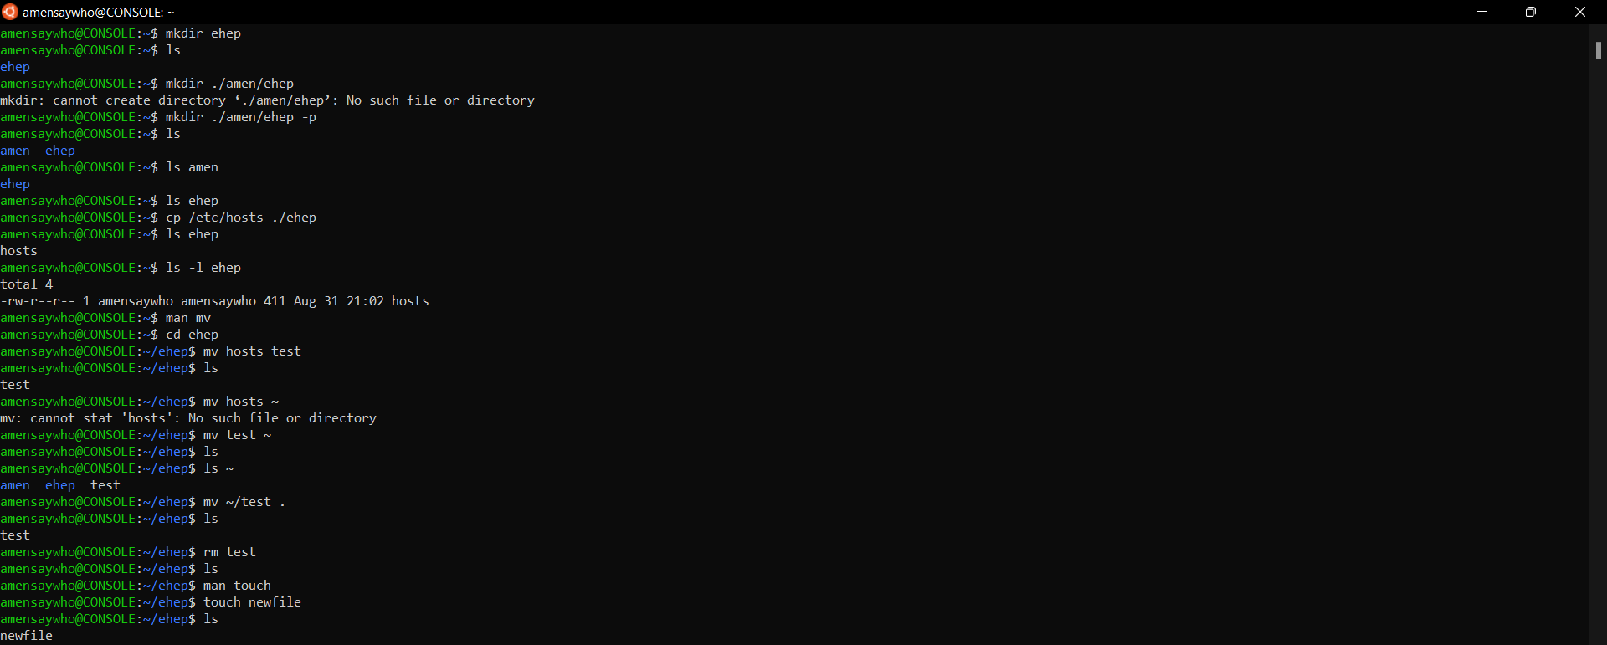

* The -p switch creates the parent folder as well if the path specified when specifying the destination of the new folder doesn’t exist.
* The mv command removes the file from the source directory. Also renames the file if the source and destination directories are the same
* The touch command creates a new file if the filename doesn’t exist in the directory. The contents are empty as we can see from the cat and wc commands

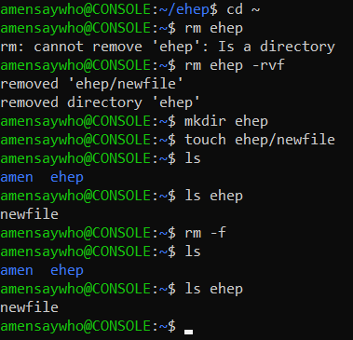

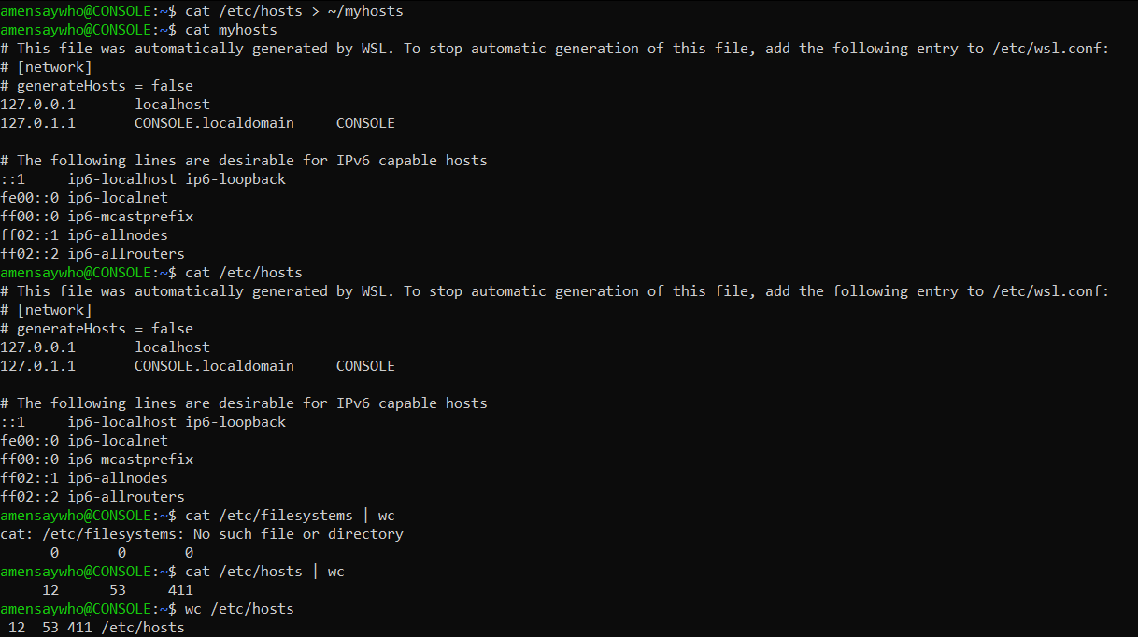

We see that > is used to redirect the output to a file (creates new if doesn’t exist), while | is used to treat the output of the 1st command as input for the 2nd command/program.

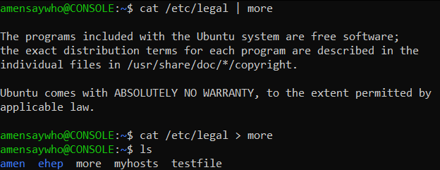

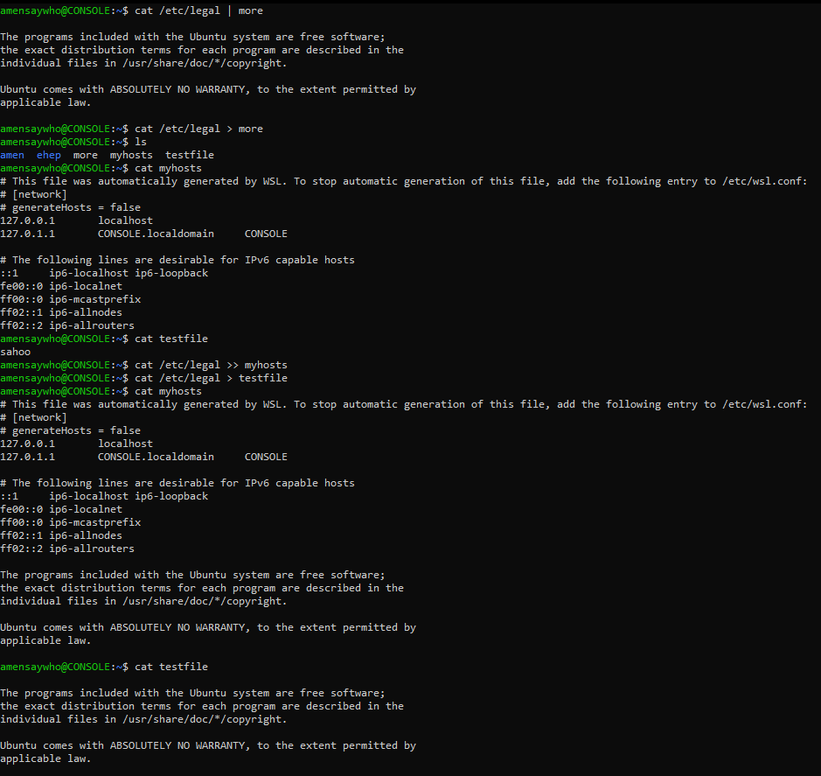

As we can see >> appends the new output to an already existing file, while > overwrites the data within the file

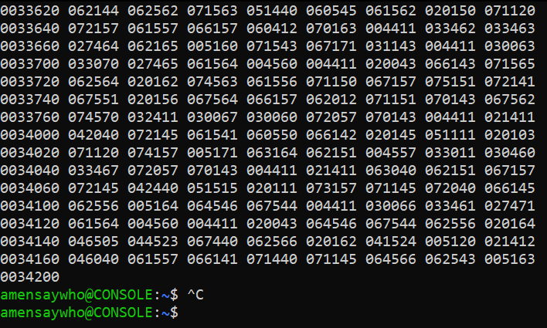

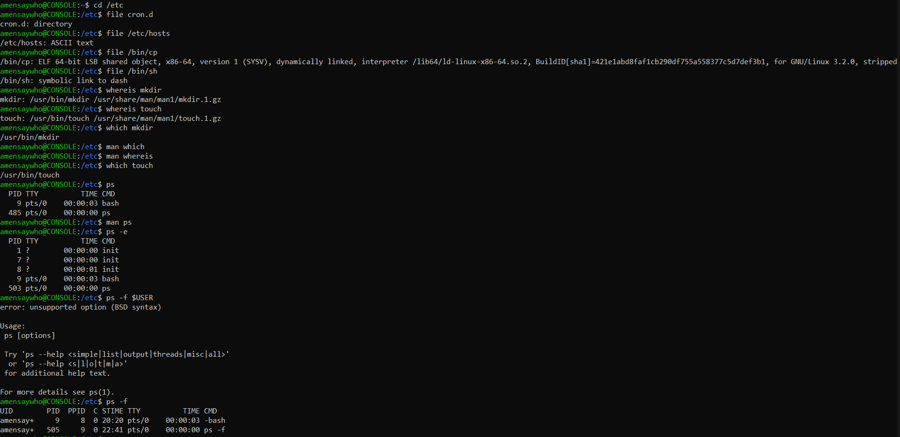

bash is the shell that processes all the input and output for linux. This bash process will run as long as the terminal is open. ps is the command that shows all processes running at the time (including itself). -e switch shows all the processes running, whereas -f gives the full formatting of the output.

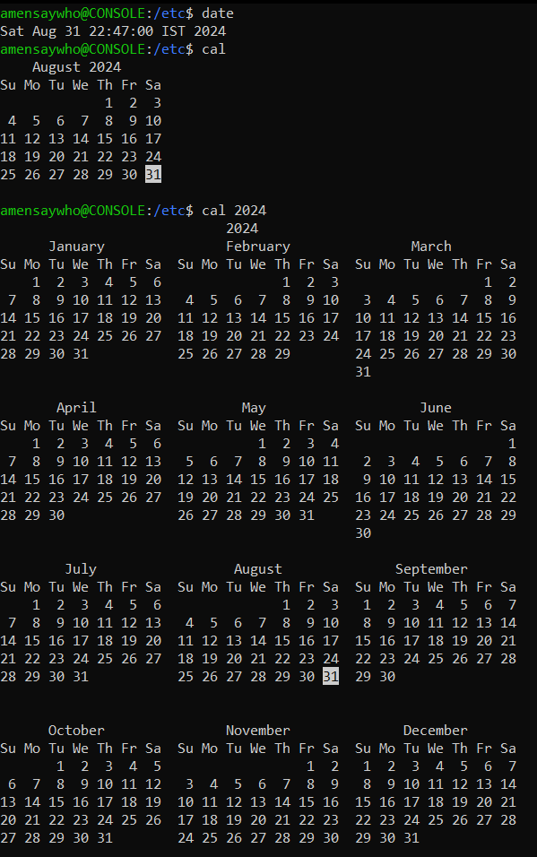

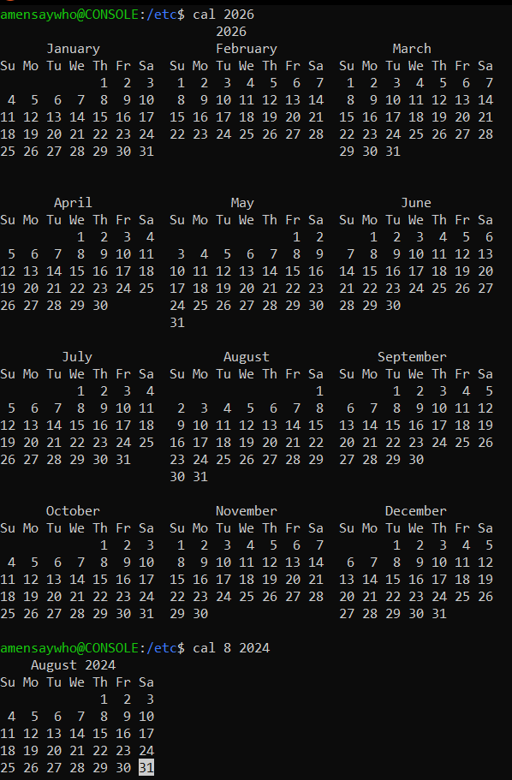

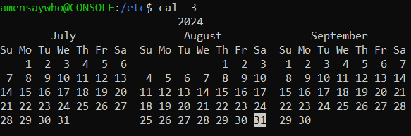

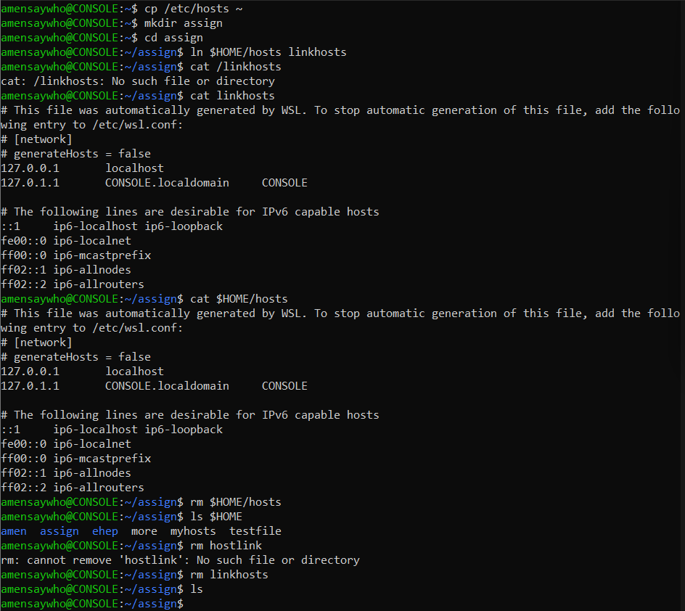

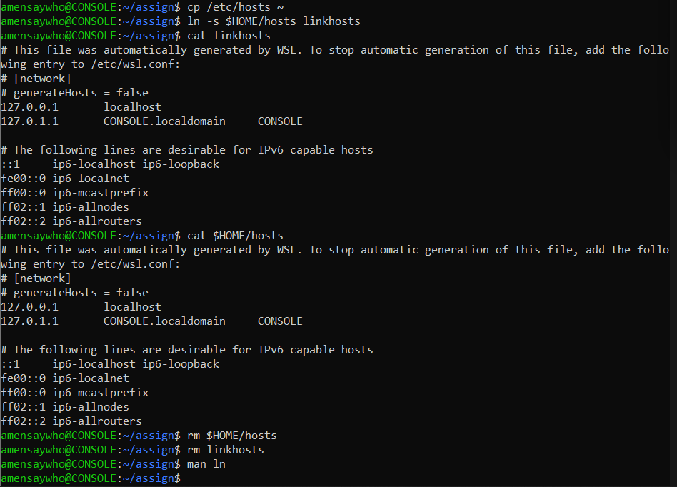

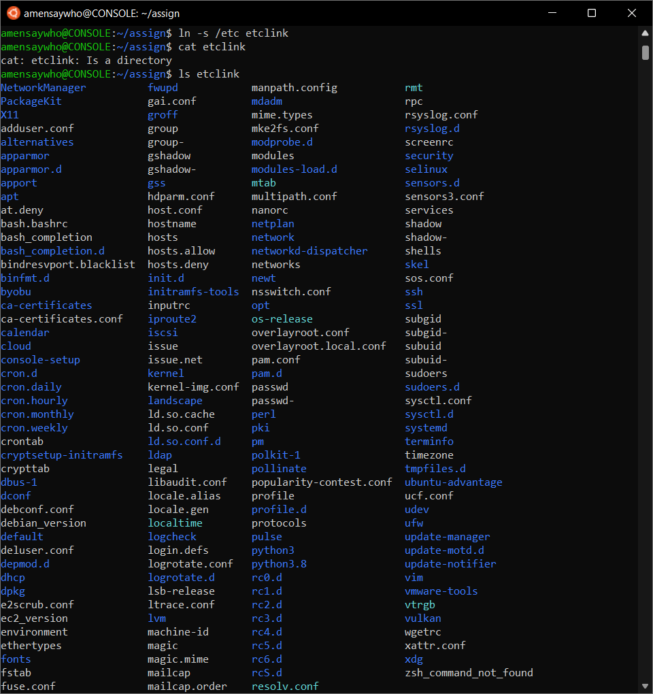

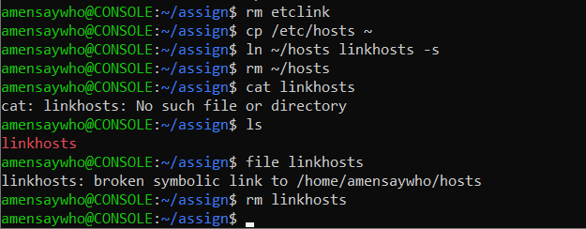

ln, by default, creates a hard link to the target file, and is unaffected by the modification of the target file. When creating a symbolic link using -s, deleting the target file renders the symlink broken. There seems to be no difference (?) in the deletion of the target file in either case.

Setting a folder as the target creates a link to the folder and its contents.

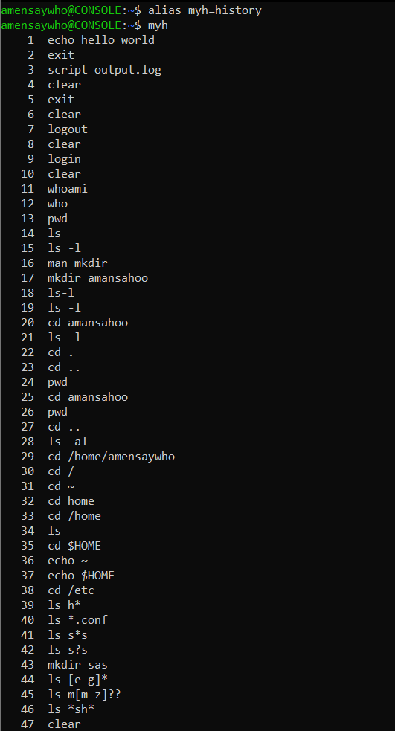

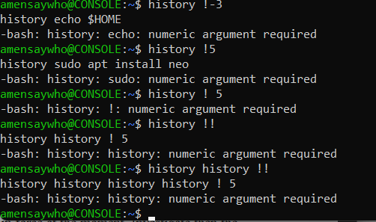

!n displays the first n items/words in the history list. If n is <0, displays the last n items. !! displays the last item.

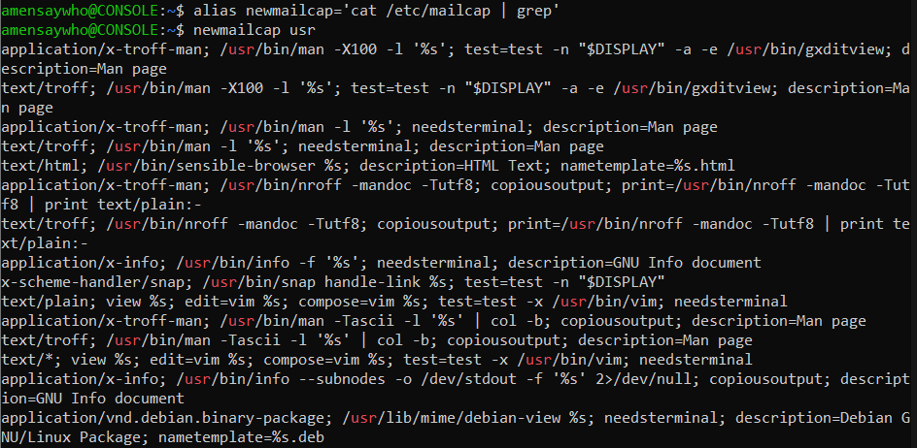

alias set a new name for the command ‘cat /etc/mailcap | grep’, i.e. it takes the output of cat (content of mailcap and pipes it to the grep command). The grep program then finds the keyword/pattern usr present within the input (contents of mailcap)

to and tou are different because the terminal has more information to predict the next command and is able to eliminate probable command due to the addition of ‘u’

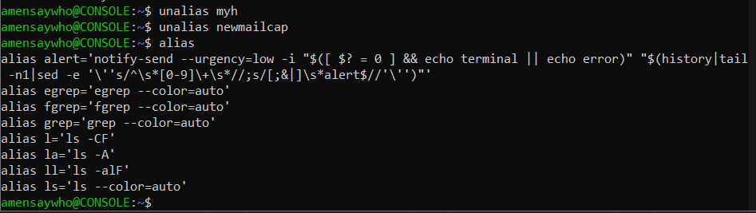

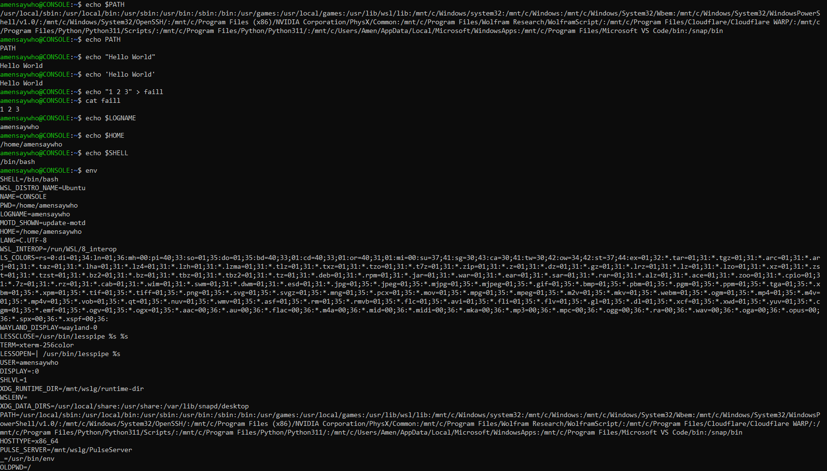

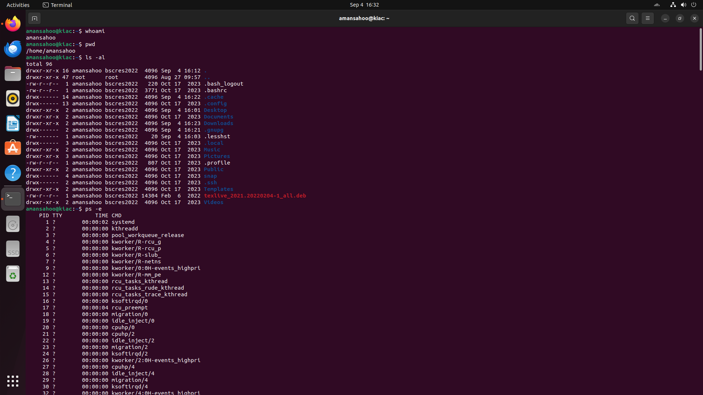

Alt-Ctrl-F5 switches to cli mode where we have to login using our credentials.

2. Some LINUX tools

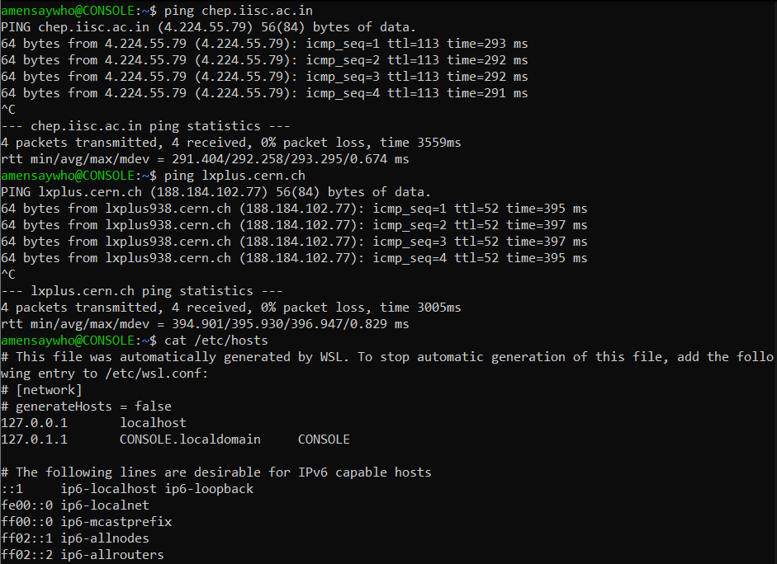

The ip address is different than the ones called localhost and CONSOLE.localdomain

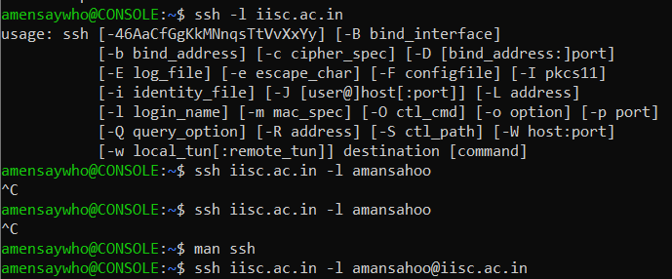

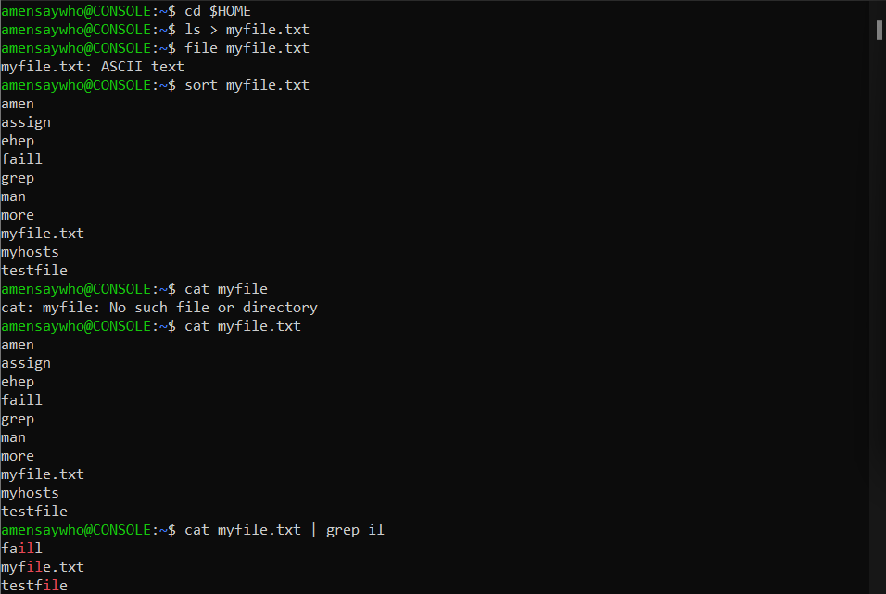

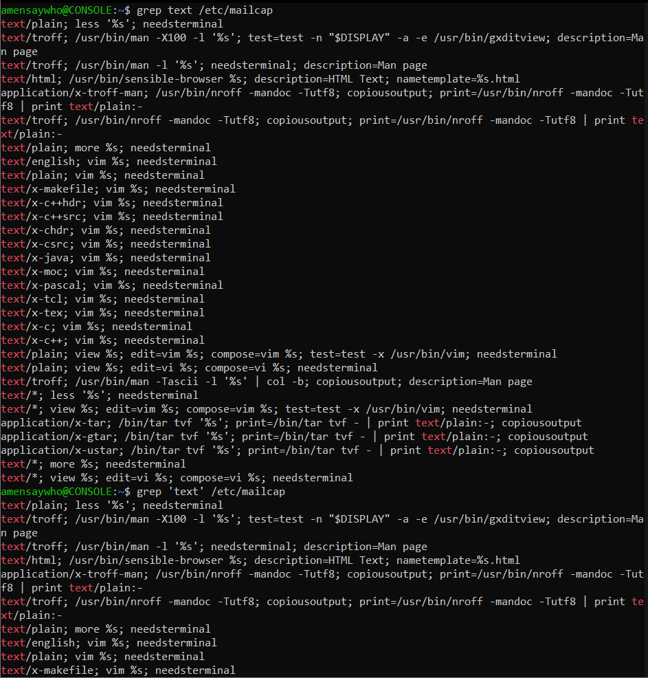

grep outputs all lines in the specified file that contain the specified “pattern” that is a string. No difference is observed by enclosing the pattern in ‘’

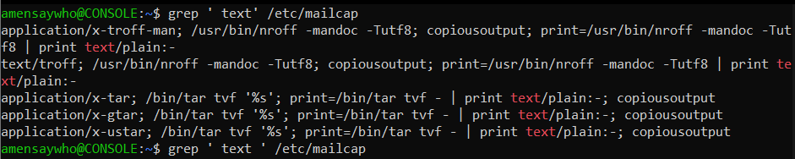

Adding a space before and after a term, while enclosed in ‘’ singles out phrases/words as desired.

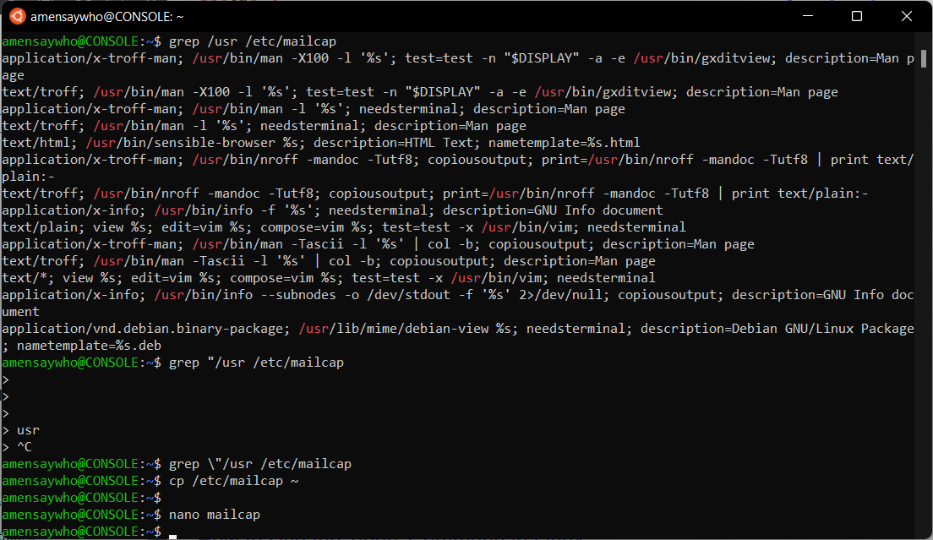

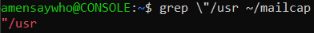

The backslash acts as an escape character that makes grep interpret the “ literally

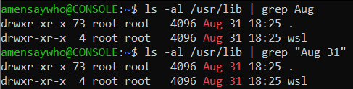

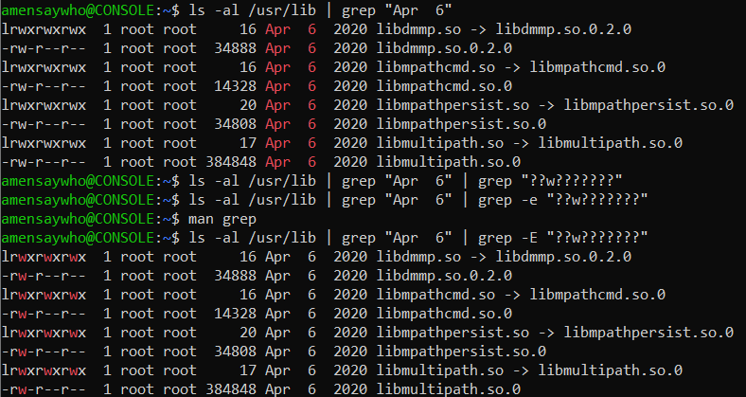

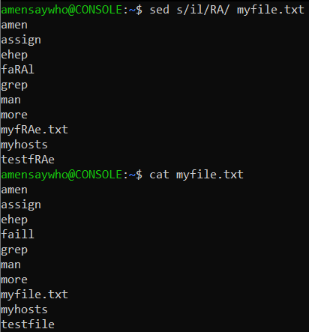

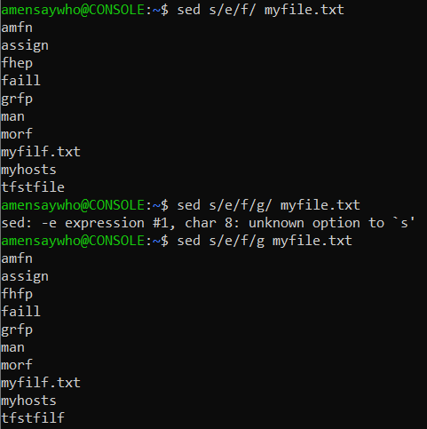

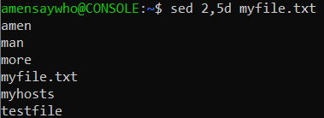

Sed takes in a text file, processes each line according to the given command and outputs the processed text. No changes are made to the actual text file. /s/[exp]/[rep] is used to substitute the first occurrence of [exp] with [rep] in every line. Adding the /g flag makes sure EVERY occurrence on every line is replaced. /d is used to delete lines containing the given expression.

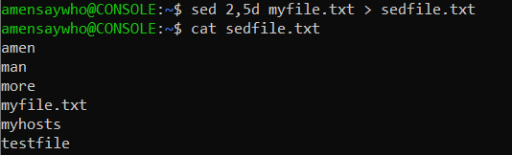

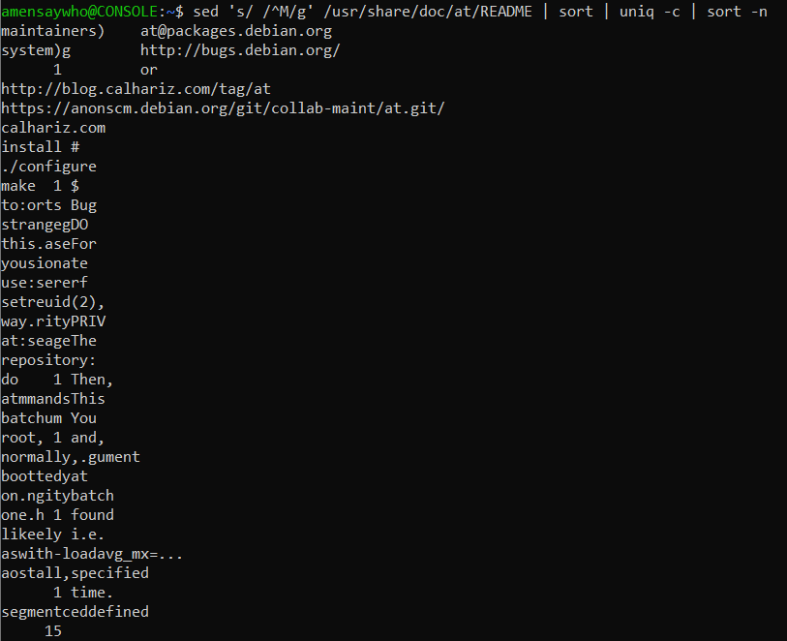

From the specified README file, all blank spaces are replaced with the carriage return character (^M) which makes the cursor go back to the beginning of the current line. The output is then piped to sort, that sorts alphabetically, the output of which is piped to uniq. uniq keeps only the unique lines and merges all recurring lines to a single line, the -c flag inserts the count of how many times a line has occurred (eg, blank line has occurred 15 times in above screenshot). The output is then piped to sort -n which sorts numerically (count number).

‘...’ is needed to quote special characters and backslashes.

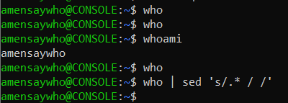

\* since who returns no response on my terminal i will use cat of a file as input for awk

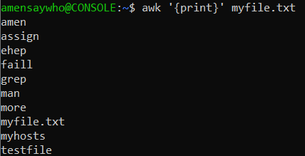

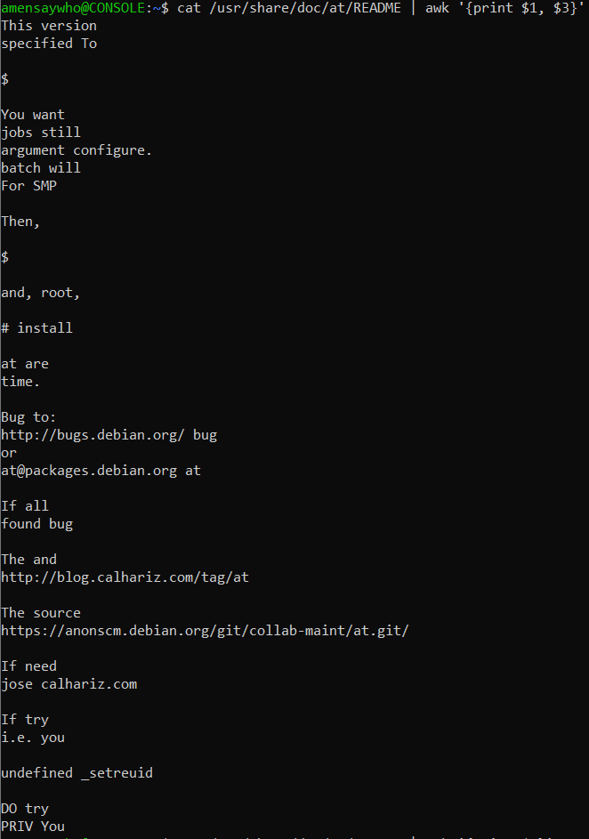

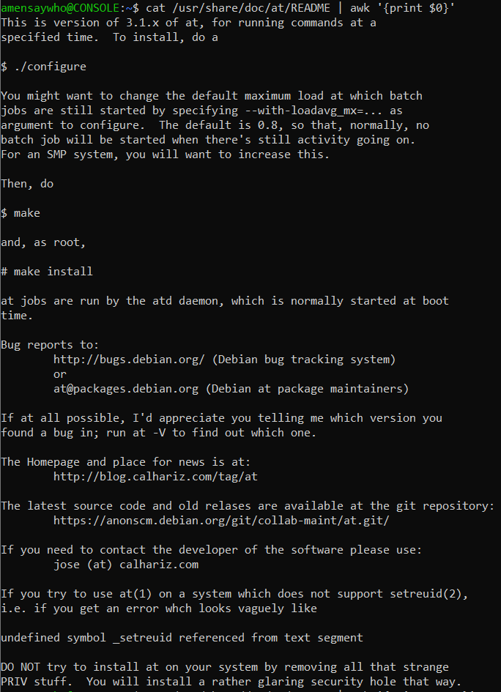

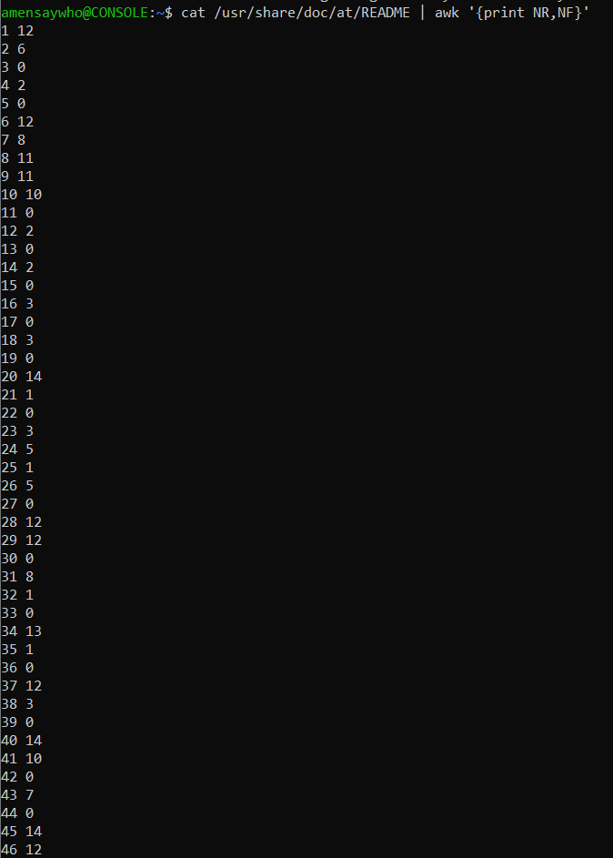

NR- Number of lines NF-Number of Fields=No. of words + 1 (full line)

* sed is a line by line text editor that uses commands to make simple text edits to the input file. awk separates the words into fields allowing for more complex operations to occur in each line.

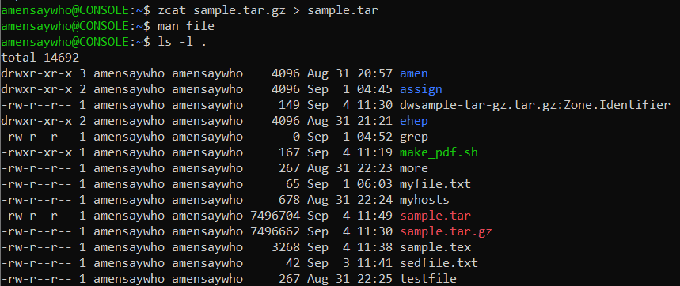

We see that the uncompressed file is slightly larger than the compressed version

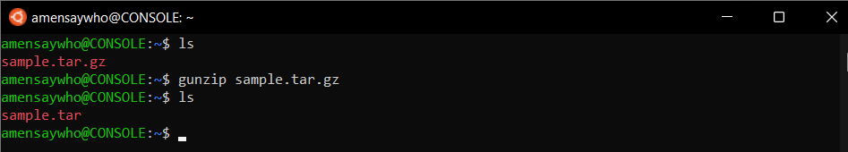

The gunzip command replaces the input file with the output file. gunzip -c is identical to the zcat command, as it keeps the input and writes the output to stdout, which can then be piped to a new .tar file (preserves the input file)

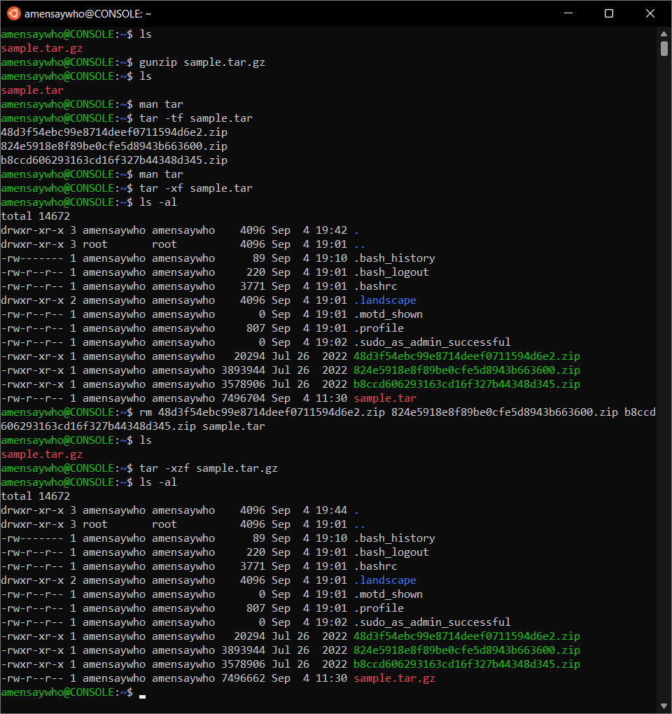

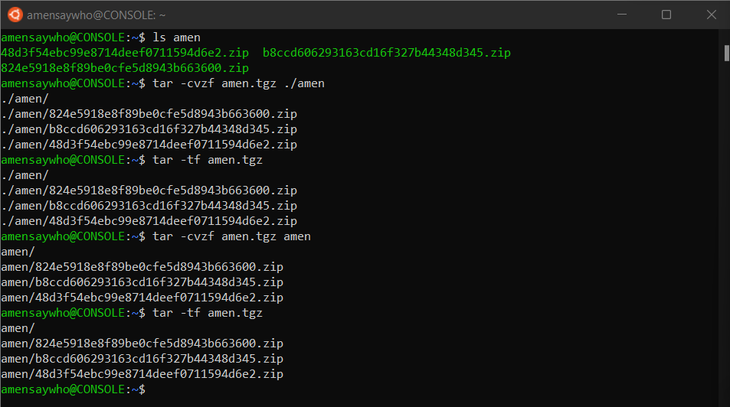

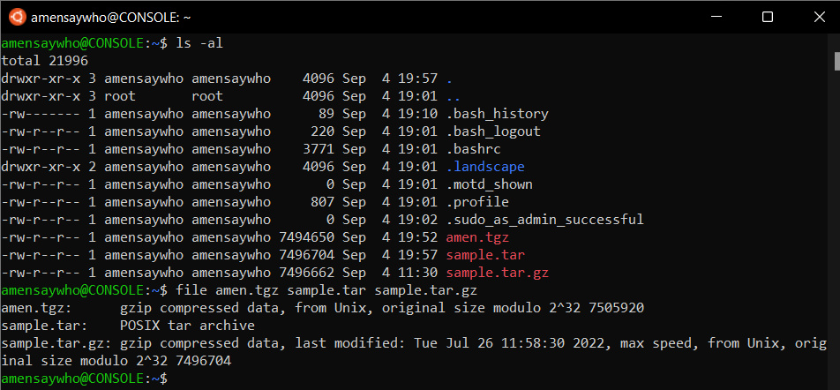

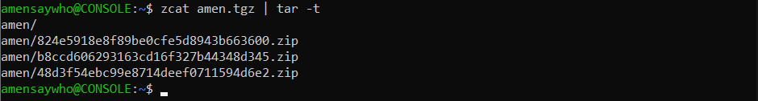

zcat processes the .tgz file and writes to stdout, which is then redirected to the tar -t command, which outputs the content of the input file it receives. No new file is created and the same could be achieved using tar -tzf.

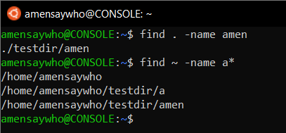

find locates all the files, directories and sub-directories in the specified path that pass the tests specified by the switches.

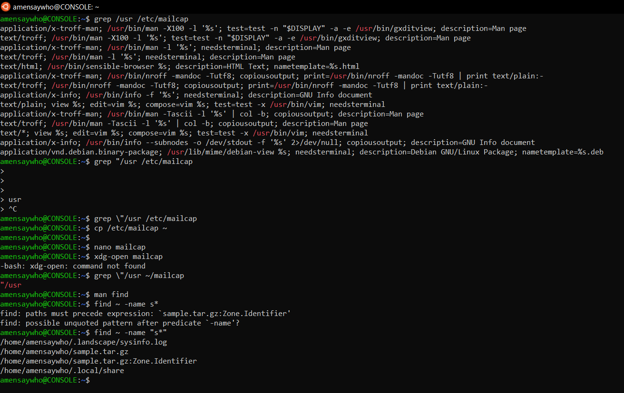

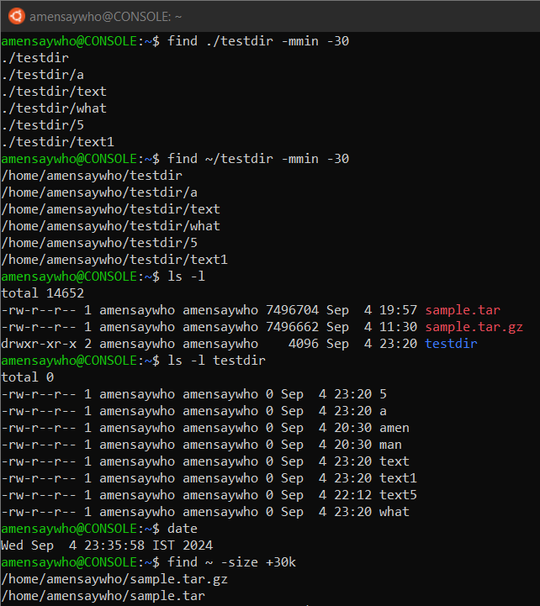

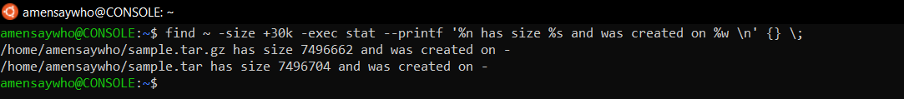

In the above case - means there was no birth time available.

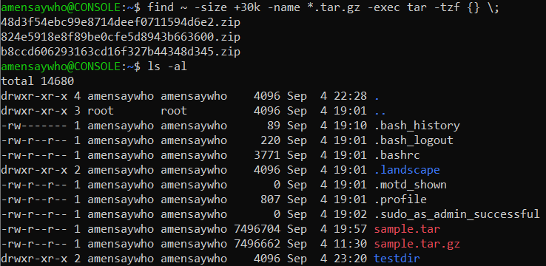

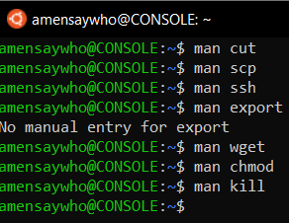

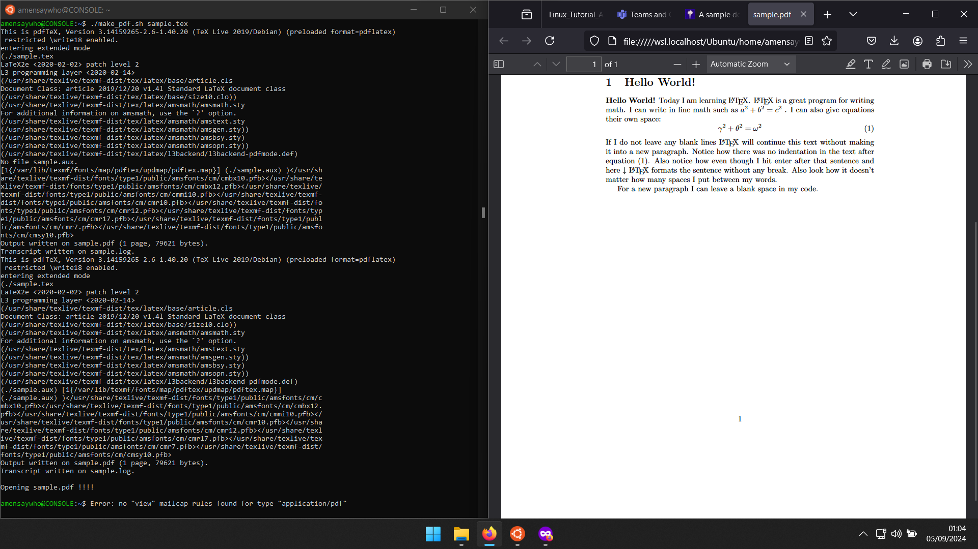

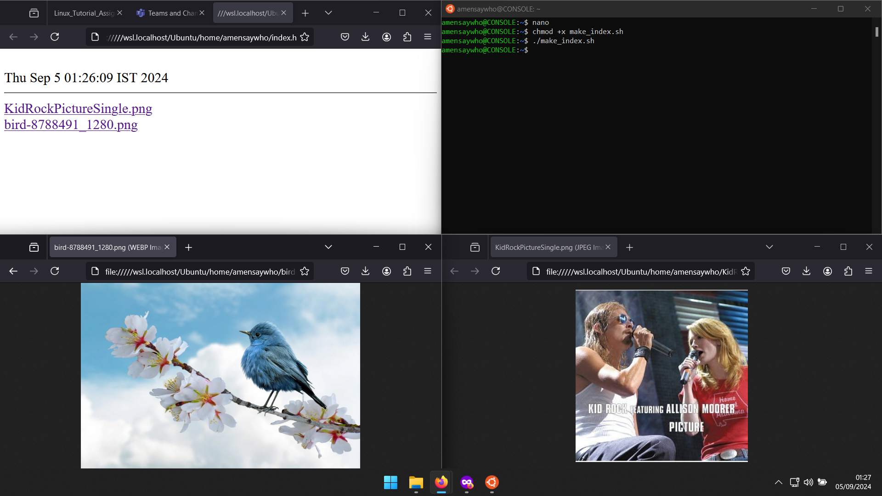

3. X-Window

Right clicking opens a context menu

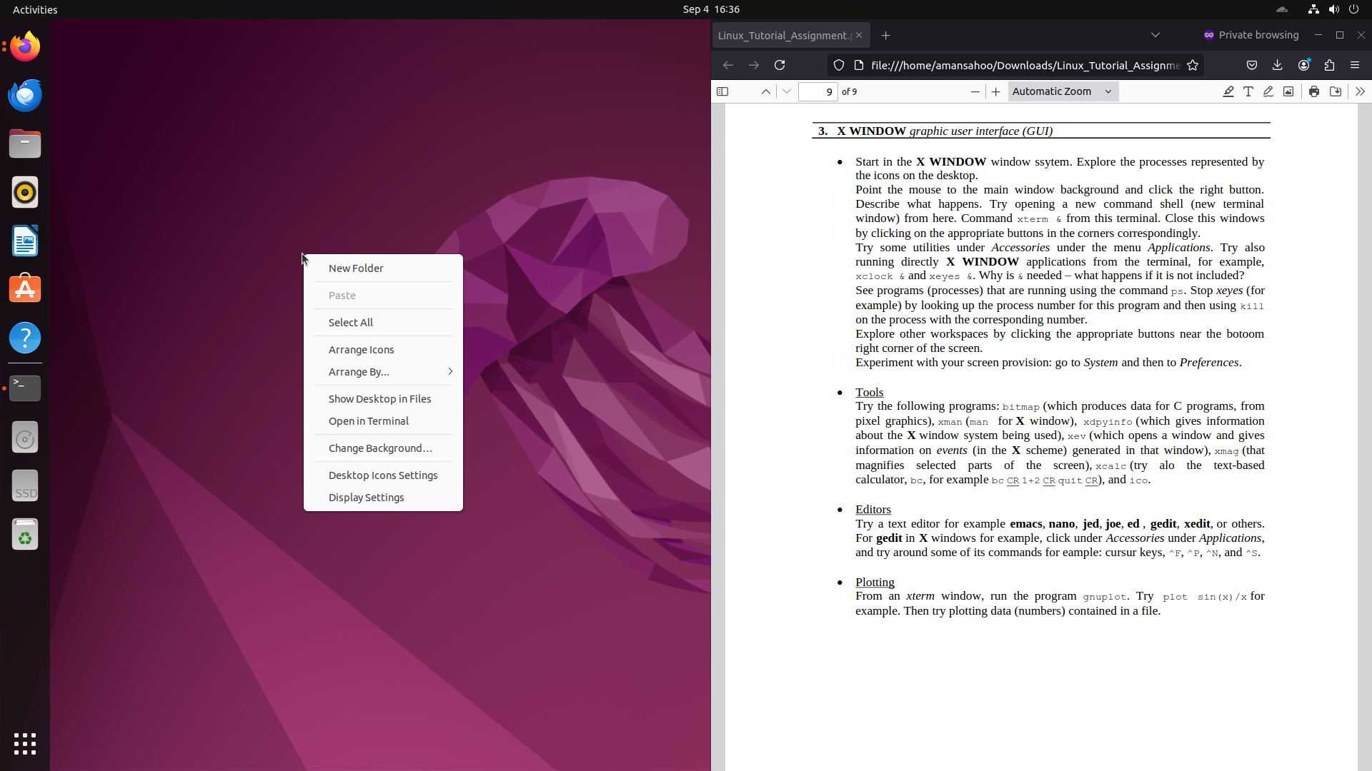

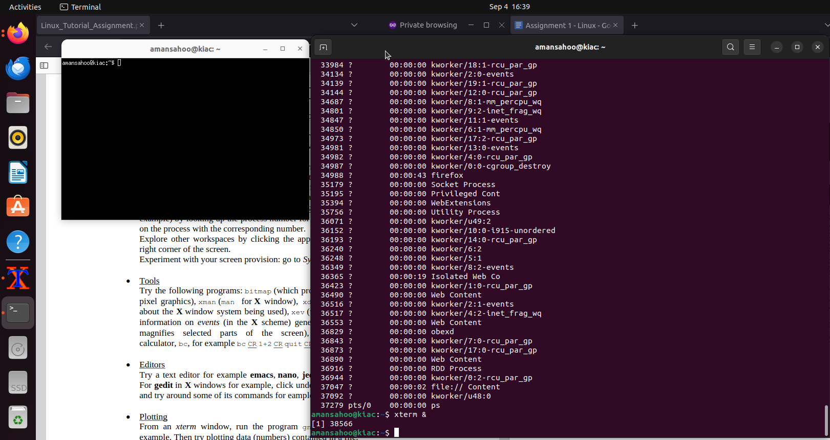

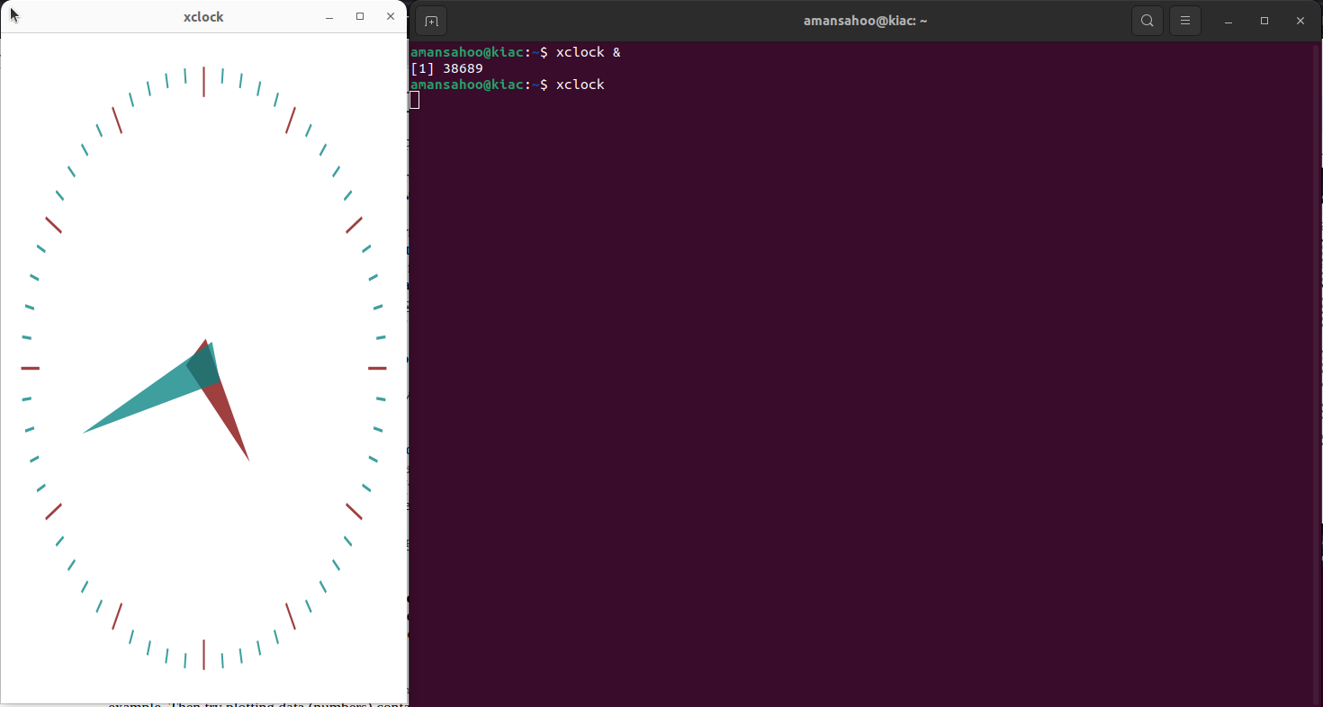

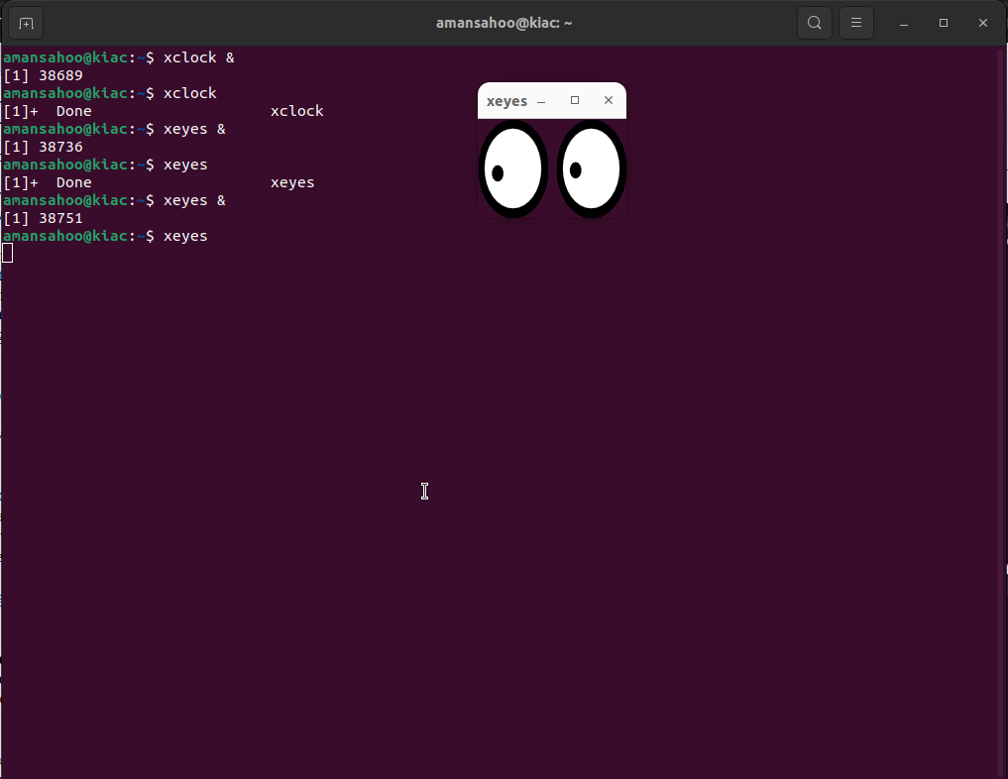

The & symbol is used to ready the terminal for the next command even if the current process is running in the background

